**KIRANA PRODUCT BILLING**

**Classification of products based on image using ML.**

**I have added the python code for classification of two Product using TensorFlow and Keras Libraries.**

**Import the necessary libraries which have been imported in python code.**

**For ML model creation, we need to train the model using dataset (images here) , test the model accuracy and then create model.**

**Explanation of the Process:**

* **First create folder with product name in "Products" folder in Model Training folder.**
* **Add the product images in that folder.(You can view the folder which contains product images in respective product folder for your reference)**
* **Also add some product images which are not present in "Products" folder images in "Validation" folder.(These images for validation of our model)**
* **We need to add more images so that model will predict the image correctly.**
* **Run the classifier.py file in Python IDLE / Visual Studio Code which will help you in creating pickle files X and Y which contains features and label in them.(The python will itself access the folder and name the product name as your folder name)**
* **On Successfull Completion you will see the image below( I have 75 images in each of product folder)**



* **Next run the cnn,py in Python IDLE / Visual Studio Code which will help you in validation and creation of ML model.**
* **Also “product-classifier.model” file will be created in same folder.**
* **Then we have copy the created model file to “KiranaApplication” folder so that it can be used for prediction.**
* **On Successfull Completion of running cnn.py,you will see the image below (Which will show you the accuracy of prediction)**

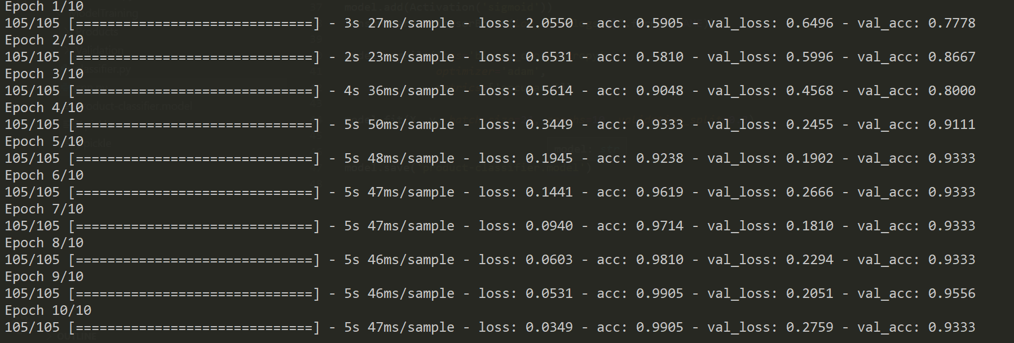

* **“KiranaApplication” folder contains the web application things.**
* **app.py is local host flask server which process the image sent to it and sends the result back to webpage and predict.py will be called from app.py to prediction.**
* **Webcam is used for capturing the image and on clicking submit the server will save the image and process the image. The prediction is sent to server.**

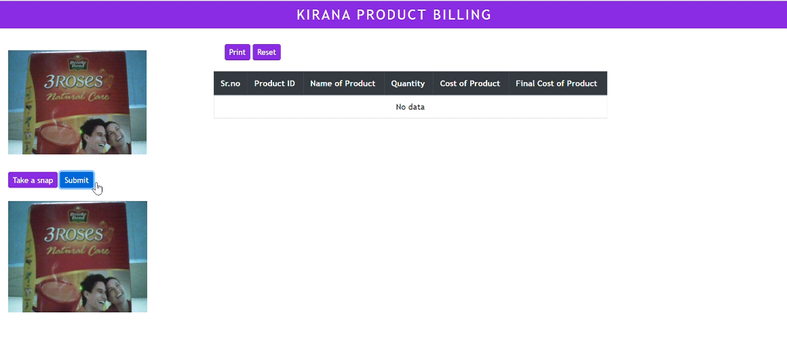

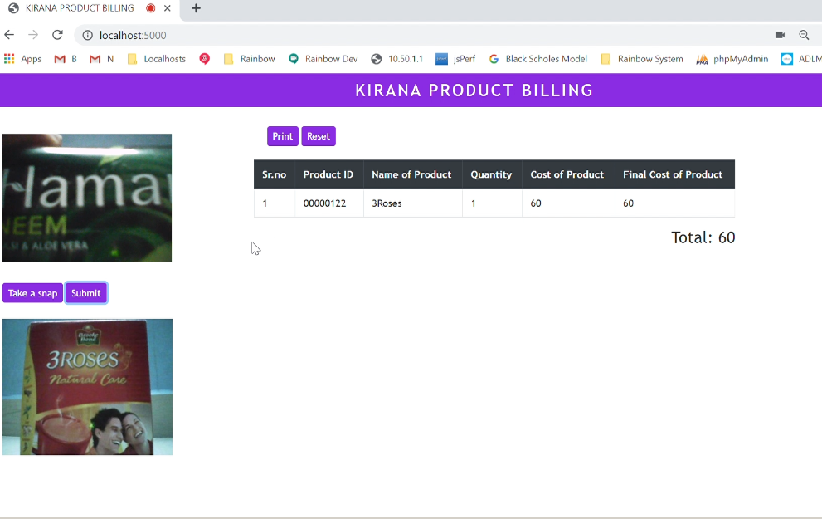

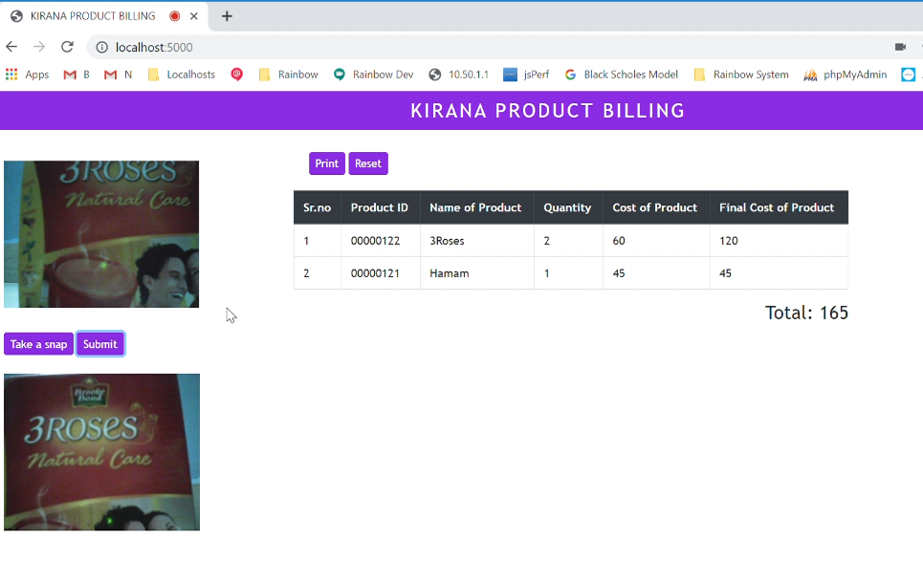

* **Print and reset button in webpage will help us to print the data in table and reset the data in table.**

**Since Tensorflow needs some hardware in CPU for processing, it might show error while running. Please search in internet for solutions.**